**DAILY ONLINE ACTIVITIES SUMMARY**

|  |  |  |  |  |  |  |  |  |
| --- | --- | --- | --- | --- | --- | --- | --- | --- |
| **Date:** | **12/06/2020** | | | | | **Name:** | **Pratibha Shetti** | |
| **Sem & Sec** | **IV sem & B section** | | | | | **USN:** | **4AL18CS062** | |
| **Online Test Summary** | | | | | | | | |
| **Subject** | | **Aadalitha Kannada** | | | | | | |
| **Max. Marks** | | **25** | | **Score** | | | **14** | |
| **Certification Course Summary** | | | | | | | | |
| **Course** | **Introduction to Ethical Hacking** | | | | | | | |
| **Certificate Provider** | | | **Greatlearning academy** | | **Duration** | | | **4.0 hours** |
| **Coding Challenges** | | | | | | | | |
| **Problem Statement1:** Given two positive integer start and end. The task is to write a Python program to print all Prime numbers in an Interval. | | | | | | | | |
| **Status: Executed** | | | | | | | | |
| **Uploaded the report in Github** | | | | | **YES** | | | |
| **If yes Repository name** | | | | | <https://github.com/pratibhashetty-123/Lockdown-coding-for-python> | | | |
| **Uploaded the report in slack** | | | | | **YES** | | | |

Online Test Summary: 18KAK49 test was scheduled from 11:35am to 12:00pm.The portion for the IA was 10chapters there were 25 questions and time assigned was 25 minutes the questions were mcq type.

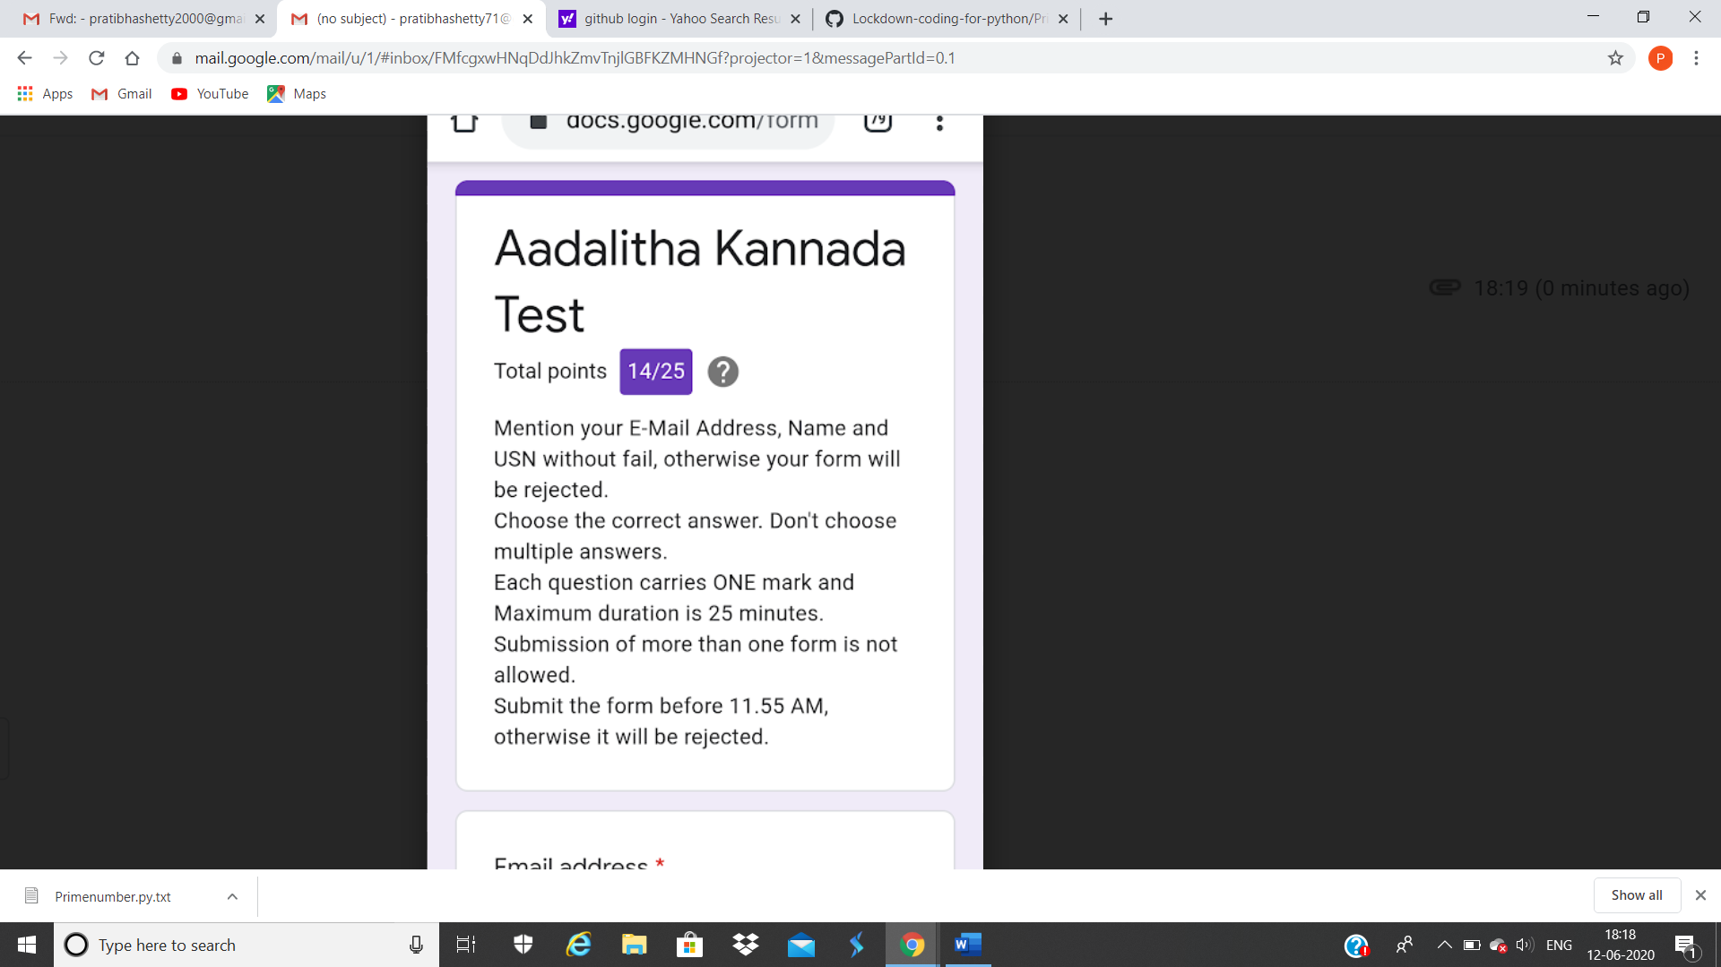

This is the completion of test and marks obtained for 18KAK49. 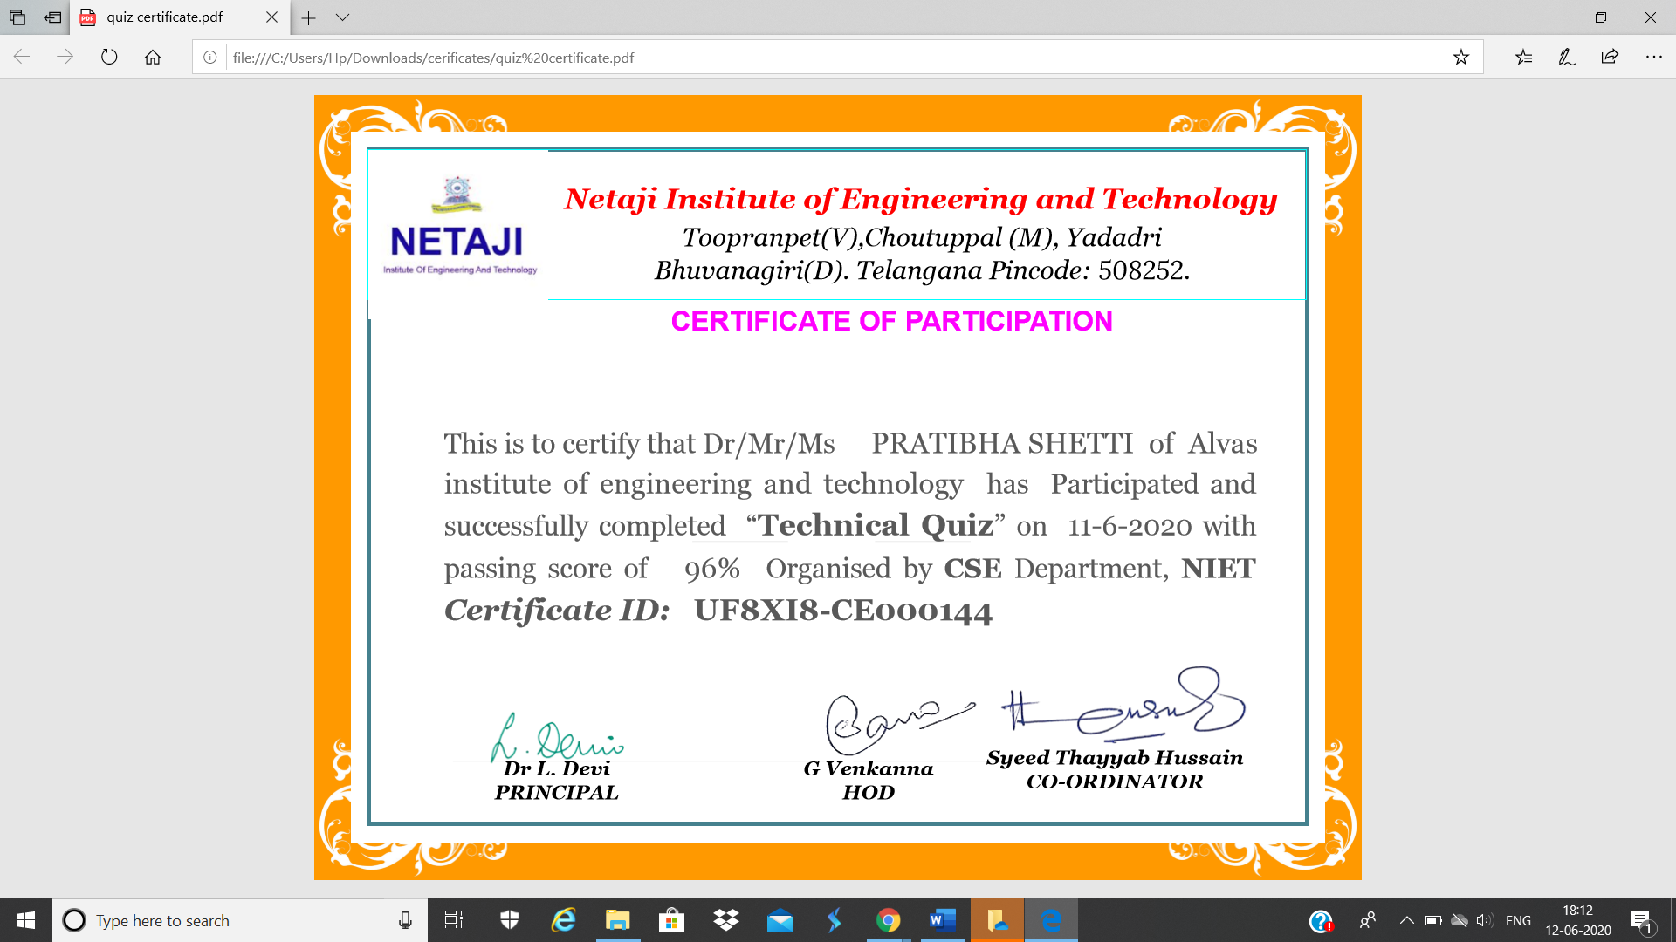

This is the certificate for attending technical quiz on 11 june

Online Certification Course Summary: In today’s session I have learnt about Ethical Hacking in Network Architecture-Demonstration. I came to know how Ethical Hacking plays a role in Network Architecture and how to implement the same.

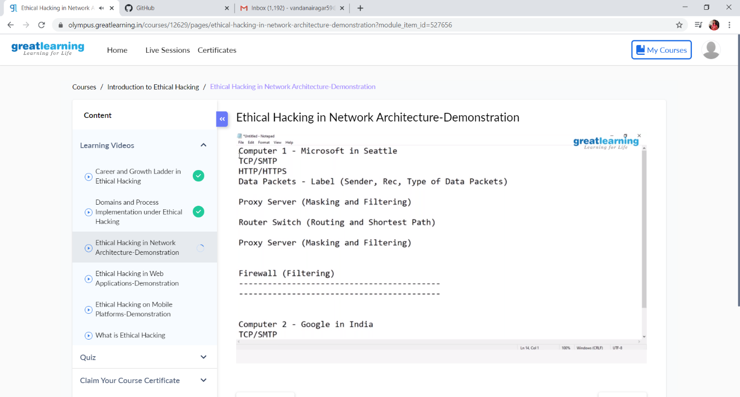

Online Coding Summary: **Today I had received one program from prof. Vasudev CSE Dept. The program is mentioned above in the coding challenges(pg.01). I have also uploaded it to my Github repository.**

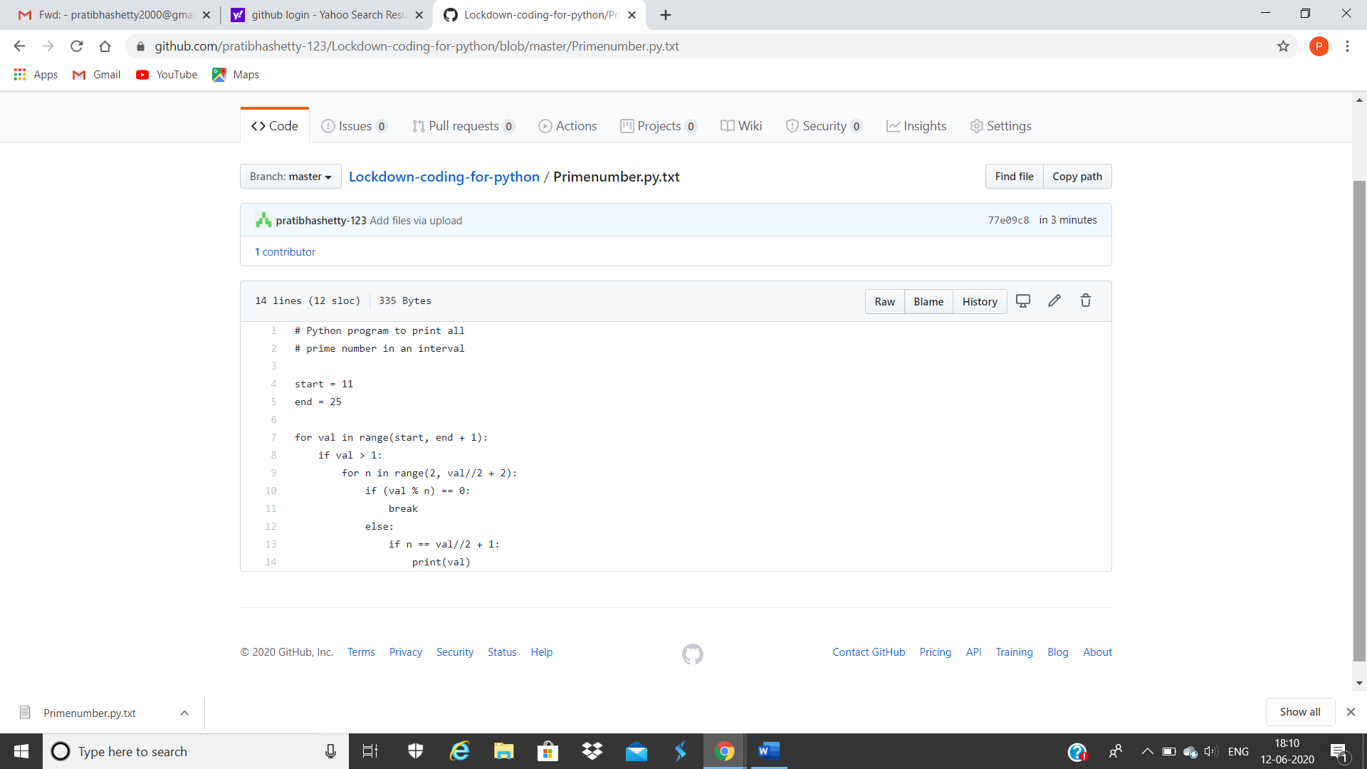

**This is the snap shot of my Github repository** were I have uploaded the code. File name is Primenumber.py